Contents

SharePoint 2013: Add a Geolocation column to a list in SharePoint 2013 programmatically 2

Description of the sample 2

Prerequisites 3

Key components of the sample 3

Configure the sample 3

Run and test the sample 3

Troubleshooting 4

Change log 4

Related content 4

# SharePoint 2013: Add a Geolocation column to a list in SharePoint 2013 programmatically

This documentation is preliminary and is subject to change.

Summary:   By using the new Geolocation field type, you can integrate location information and maps in SharePoint lists and create location-based websites for SharePoint 2013 Preview.

SharePoint 2013 Previewintroduces a new field type named Geolocation that enables you to annotate SharePoint lists with location information. In columns of type Geolocation, you can enter location information as a pair of latitude and longitude coordinates in decimal degrees or retrieve the coordinates of the user’s current location from the browser if it implements the W3C Geolocation API. (For more information on the Geolocation column, see **Integrating location and map functionality in SharePoint 2013**.) The Geolocation column is not available by default in SharePoint lists. To add the column to a SharePoint list, you need to write code. This article shows you how to add the Geolocation field to a list programmatically by using the SharePoint client object model.

## Description of the sample

This sample demonstrates how to programmatically add a Geolocation column to a SharePoint 2013 Preview list. In the list, SharePoint 2013 Preview displays the location on a map powered by Bing Maps. In addition, a new view named Map View displays the list items as pushpins on a Bing Maps Silverlight control with the list items as cards on the left pane. Figure 1 summarizes the default location and map features in SharePoint 2013 Preview. Together, the Geolocation field and the Map View enable you to give spatial context to any information by integrating data from SharePoint into a mapping experience, and let your users engage in new ways in your web and mobile apps and solutions.

Figure 1. Summarized view of the default location and map features

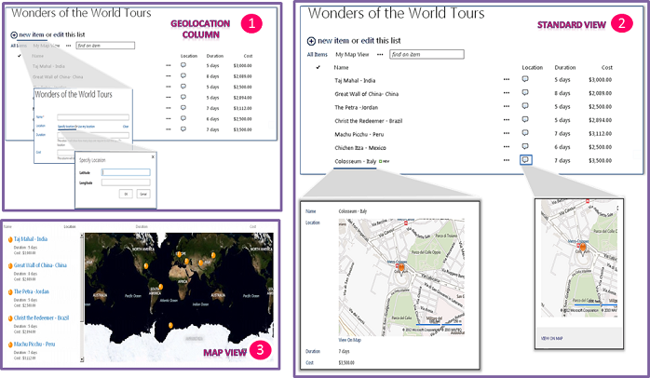

## Prerequisites

This sample requires the following:

* Visual Studio 2010
* An installation of SharePoint 2013 Preview with administrative privileges
* A valid Bing Maps key added at farm or web level

## Key components of the sample

The AddGeolocationFieldSample code sample contains the Program.cs file. Program.cs contains the logic of the console application, which deploys the Geolocation field to a specific list.

## Configure the sample

To configure the sample, make the following changes to Program.cs.

1. Replace the "http://localhost" server name with the URL of your SharePoint server.
2. Update the <List Title> element with the title of the list name where you want to deploy the Geolocation column.

## Run and test the sample

* Choose the F5 key to build and deploy the console application.

## Troubleshooting

The following table lists one common configuration and environment error that might prevent the sample from running or deploying properly and how to solve it.

| Problem | Solution |
| --- | --- |
| After adding an item to the list, Bing Maps shows an error. | Set the Bing map key at farm or web level. To learn more how to set the Bing Maps key, see **How to: Set the Bing Maps key at the web and farm level in SharePoint 2013**. |

## Change log

| Version | Date |
| --- | --- |
| First version | July 16, 2012 |

## Related content

* **How to: Add a Geolocation column to a list in SharePoint 2013 programmatically**
* **How to: Set the Bing Maps key at the web and farm level in SharePoint 2013**
* **How to: Create a custom Geolocation field that renders using Nokia Maps**